Lecture 14: The Effects of Air and Water Pollution

Professor Raj Chetty, Harvard University

Introduction to Environmental Economics
- Below is a simple graph showing trends in global temperature and carbon dioxide concentration.
  - The line shows CO2 concentration and the bars show average global temperatures. The mean over this period, from 1880 roughly to the present, is 57 degrees Fahrenheit. The earth is getting warmer, and we also are seeing a tremendous increase in carbon dioxide and carbon emissions. Scientists believe—with good evidence—that those two things are linked to each other.
- Economists approach the objective of reducing climate change from a cost-benefit perspective, analyzing tradeoffs between carbon dioxide emissions and considerations like efficiency and higher incomes.
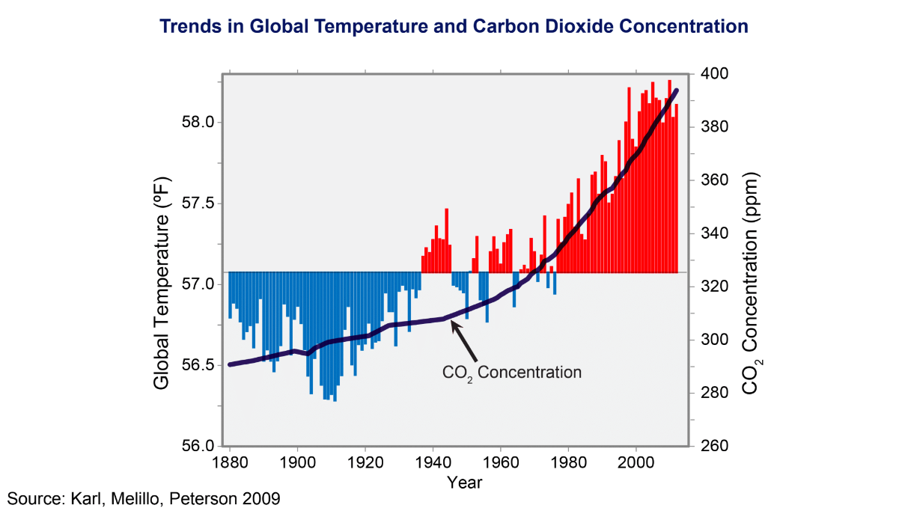
- In order to understand the trade-off between the economic benefits of doing things like emitting more carbon and the environmental costs, we must price the environmental damage created by any given policy.
  - If we loosen restrictions on what plants are allowed to do or the types of technology that people are allowed to use in cars, there is going to be a benefit, perhaps in terms of making cars cheaper or better in some way. There is going to be some cost to the environment. We need to be able to price the environmental damage to be able to speak in scientific, rigorous terms about whether we want to move in a particular direction or not.
- The second key feature of the economic approach is that we do not take human behavior as fixed. We recognize that humans adapt to changes in conditions, to changes in policies, but also to changes in climate.
  - For instance, the simplest example of that, when it gets really hot, humans have developed technologies to try to deal with that, namely air conditioning. Air conditioning itself has its own problems, and emissions created by air conditioning could worsen the problem of environmental damages. The key thing is to realize that there is going to be some adaptation in equilibrium as the climate changes. For instance, people might not live near the coasts that are getting flooded, or they might build different sorts of barriers, like what is being done in the Netherlands now, for example.

Externalities
- The concept of an externality is very simple; it is capturing a case where one person's behavior, like what I do, directly affects another person's wellbeing or another person's utility.
  - For instance, if you drive a car that emits pollution, that does not have a big cost for you yourself. The bigger cost we are concerned about is that it affects everyone else in society. If you are just trying to maximize your own wellbeing, you may drive a car that emits a lot of pollution but we do not want to let you do that because you are harming lots of other people in the process.
- Tackling externalities requires different types of data to measure these costs, so we will use a different set of methods relative to what we have been talking about in previous lectures. It is also going to require different types of policy approaches. In particular, we are going to need to measure the impacts of certain policies or certain behaviors on everyone not just on a given person's income or health.
- The second difference with externalities is that because we are concerned about how one person's behavior affects other people, the goal is often to change people's behavior to encourage them to move away from what is in their best interest. Here, we are interested in changing people's behavior to achieve social aims rather than individual benefits.
- Concretely, first: how can we measure the social cost of pollution? Second: what policies can we use to reduce pollution and improve the environment?

Social Costs of Climate Change and Pollution
- Researchers have estimated the social costs of many different types of pollution, from toxic air pollution to water pollution. The type of pollution that has received the most attention, perhaps because of its great importance, is carbon emission. Given the link between carbon emissions and climate change, researchers have studied exactly how costly additional carbon emissions are and how we might regulate them going forward.
  - In particular, that has been distilled into something people call estimates of the social cost of carbon that governments now use systematically when evaluating alternative policies. The conceptual question that people are seeking to answer in the literature is how much does an additional unit of carbon emissions cost society due to environmental change?
- This question is the subject of ongoing research, but quite a bit of progress has been made. At a high level, there are three broad steps that people take in estimating the social cost of carbon.
  - Predict the impact of 1 extra ton of CO₂ on climate using a climate forecasting model
  - Measure the impacts of changes in climate on economic productivity, health, property damage, etc.
  - Calculate current social cost by converting future costs to current dollars (discounting)
- The first thing we need to do is figure out what the impact of one extra ton of carbon dioxide emissions on the climate is. That process will use some climate forecasting model.
- Now that we have some sense of how the climate might change when we have more carbon emissions, the second step is to ask how is that will affect the various things that enter people's utility functions and affect human welfare?
- Third, we calculate the costs of that sequence of damages, which started with change in the climate and then had downstream impacts on human welfare. That is going to accrue over a series of years going into the future. Some of that will happen next year, some of that will happen 10 years from now, and some of that will 100 years from now when things might be much worse than they are at present if we do not control carbon emissions around the world. We need to figure out some way to add up those costs and convert them into a present value.
- The way people usually think about present value is that money you get later is worth less than money at present. We tend to discount the future relative to the present. That raises the question of how we should discount those future costs to current dollars, which is a third area of research and a third critical ingredient in these calculations.
- Steps two and three are what we will focus on, since step 1 is primarily outside the domain of pure economics.

Estimating the Impacts of Climate Change
- There are a number of recent studies that estimate the causal impacts of climate change on a variety of different outcomes. The key here is to do comparisons across time within areas, rather than comparisons across areas because comparing across areas can introduce many confounding variables.
- In particular, we will discuss a study by Carlton and Hsiang where they compiled results of several studies that people have done on a variety of different outcomes, relating these high frequency temperature changes within areas to outcomes. The following graph shows that growth rates are much lower when there are extreme temperatures that deviate from 15 to 20 degrees Celsius.
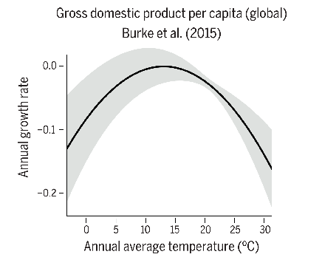
- Another version of this is to look within the United States and look at total income per capita. This is the same kind of analysis as before from a different study, and a very similar pattern emerges except on the low end there is not much of a decline if it gets particularly cold.
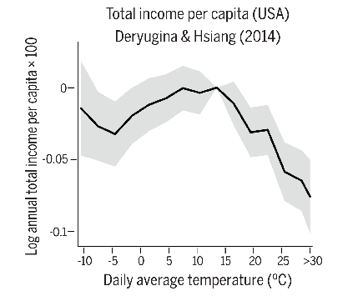
- When it gets extremely hot, there is a very sharp decline in total incomes per capita relative to other years. This phenomenon is because there is a sweet spot, an optimal temperature. By simply looking at agricultural output as a function of temperature, we can understand why the GDP/temperature relationship holds.
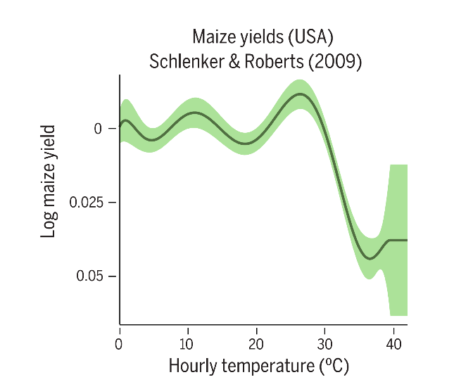
- Looking at maize yields, if it gets extremely hot, farmers lose their crop. The productivity of agriculture falls, and in particular maize yields fall very sharply if it gets too hot. However, agriculture is now a small part of GDP in the US and most other developed countries, so it is hard to imagine that the link between temperature and GDP overall is entirely driven by technological effects in agriculture. This next study is looking at math test scores.
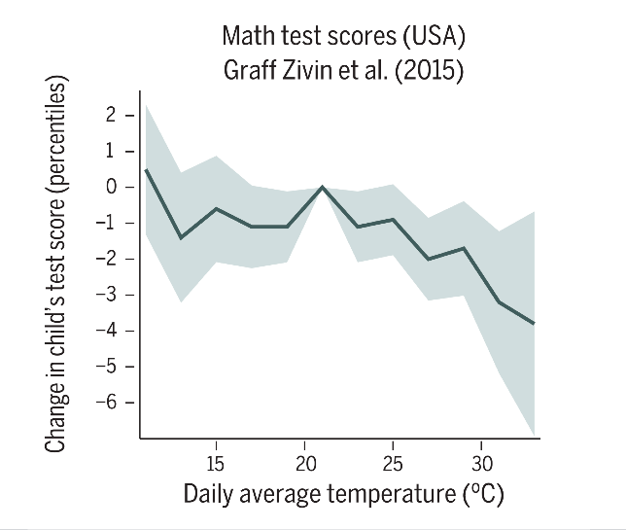
- It looks at how hot it is when students take tests, relative to average temperatures and how that affects scores. In hot years they have worse performances. On the hottest days, students are scoring four percentiles lower than if they are taking a test on a day with optimal temperature. That shows that there are effects go beyond agriculture.
- We can also look at some broader sets of outcomes beyond productivity measures. This is another example using modern data, and it looks at the use of profanity in social media posts.
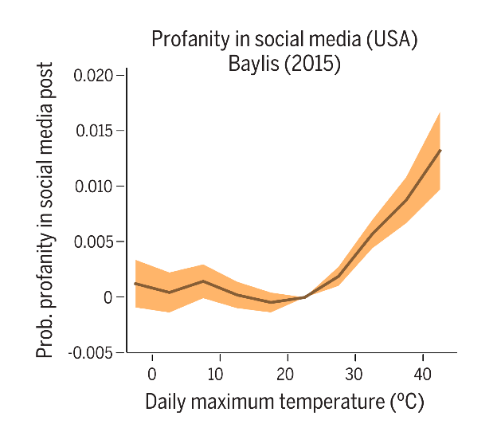
- When it gets really hot, people are much more likely to use profanity in social media posts. This is another way to show that people are unhappy during extreme weather events.
- If we look at rates of mortality from this study in Italy, we again get a U-shape, where temperatures near the middle produce lower rates of mortality than very low or very high temperatures.
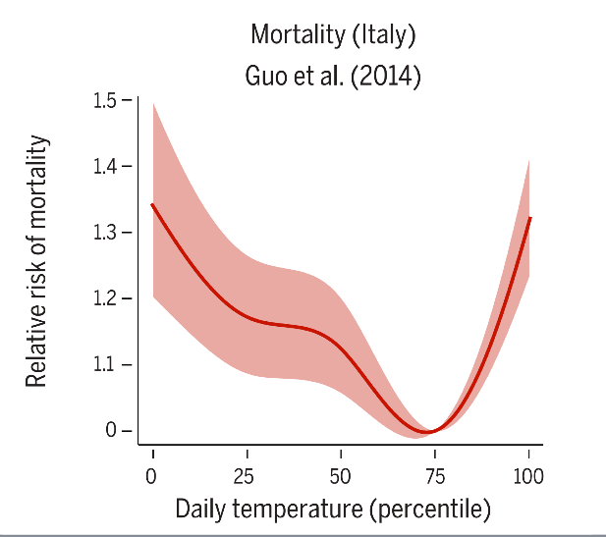

Impacts of Air Pollution using Difference-in-Differences Methodology
- In a study by Isen et al. they examine the impacts of air pollution on children's long-term economic outcomes. They use administrative data from Census and tax records to examine how pollution in an individual’s birthplace affects your employment and earnings at age 30.
- In order to do that, they need a source of variation in pollution that looks like a randomized experiment, or a quasi-experiment. A very useful tool in this context that a number of researchers have exploited is the Clean Air Act, which was enacted in 1970 in the United States. The Clean Air Act placed a ceiling on total suspended particulates that all counties in the US had to follow.
  - If a county was above that level, US law required that they had to bring air pollution down to that level. Some counties were not that polluted to begin with. Other counties were not below that ceiling, so they had to make active efforts with their local industry to reduce air pollution and come below the newly imposed ceiling.
- This type of setup is incredibly useful for research because it leads to differential changes in pollution across counties that effectively provides a treatment group and a control group, and sets up a natural quasi-experiment. In particular, it sets up a difference-in-differences design, which is a very widely used quasi-experimental method. The effects of the CAA on Air Pollution are shown below.
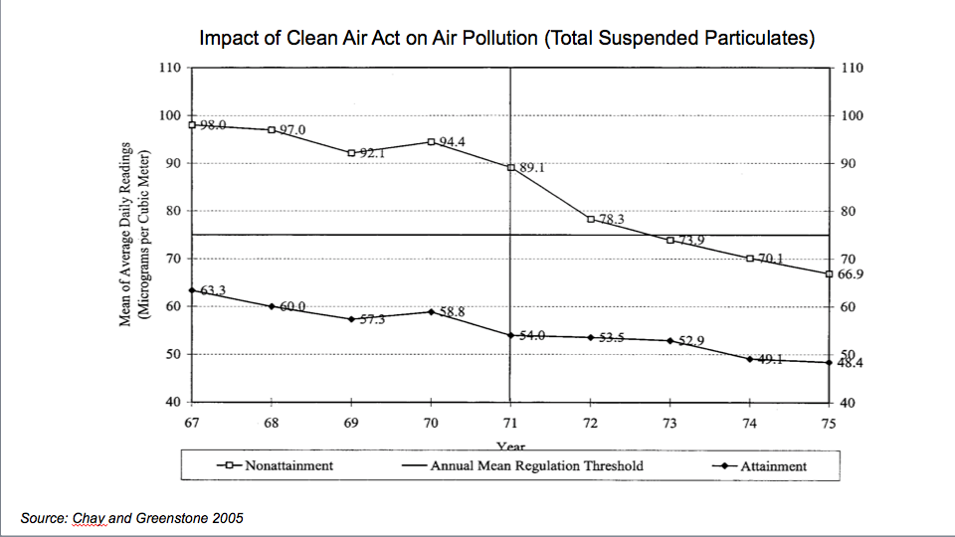
- This chart, from a paper by economists Chay and Greenstone in 2005, plots average daily readings of a measure of air pollution, total suspended particulates, in two groups of counties in the United States. The attainment counties, plotted on the lower curve are counties that were already in compliance with the threshold that the government imposed. The threshold, or ceiling, is shown by the horizontal solid line around 78.
- The non-attainment counties were above the ceiling that the federal government imposed, so they had to come into compliance with the law. Total pollution in those places falls steeply over the next few years, such that by 1975 they are below the threshold as well.
- This is useful because it sets up a difference-in-differences quasi-experimental methodology where researchers can exploit the differential changes in pollution across counties to implement a treatment control. In this case, it is not truly randomized but by comparing the differences in outcomes in the treatment areas versus the control areas before versus after a policy change we can potentially get a result that is almost as compelling as having a randomized experiment.
- To calculate the differences-in-differences estimate there are three steps.
  - First, we find the change in the average level of the outcome, pollution for the treatment group. That is the average of the upper right region minus the upper left region. Call this TA (treatment after) minus TB (treatment before).
  - Second, we find the change in the average level of the outcome for the control group. That is the average of the bottom right minus the average of the bottom left or CA (control after) minus CB (control before).
  - Third, we find the difference between the average change for the treatment group and the average change for the control group. That is why the methodology is called difference-in-difference because we take two the difference of differences.
- Difference-in-differences is a powerful econometric method to arrive at a causal effect estimate. It allows us to compare before and after, and not mind the changes that happen in between time periods since we are subtracting that effect across groups. More generally than this experiment, say there is a policy change at the federal level, and we are interested in average outcomes for kids after versus before. The problem with that is that other things may have changed between 1967 and 1975, like improvements in health technology or healthcare, or changes in the economy. It is not convincing that we have isolated the causal effect of that one policy. We can also compare places that had more pollution versus the places that had less pollution. That is problematic because the places that had more pollution might be more urban or they might be in different parts of the country. They might be different than places with less pollution for numerous reasons.
- The idea of the difference-in-differences approach is combining both of those things; we net out whatever other changes might have happened in terms of healthcare or economic activity over this period by comparing the treated areas to the control areas. We may see a bigger change, perhaps, in the treated areas and outcomes relative to the control areas. That is going to provide a more convincing case that the effect is specifically because of the change in pollution that kids' earnings or employment or other outcomes changed down the road.
- To make that logic a little bit more precise, the key identification assumption that is underlying a difference-in-differences approach is the parallel trends assumption. That assumption says that absent the policy reform that actually occurred, the outcomes would have trended similarly across the treatment areas and the control areas. Like with all of these quasi-experimental designs, this is an assumption that must be made. It does not necessarily need to hold. It could be that the trends in one set of areas are just different from trends in other areas. If this assumption holds true, however, then this difference-in-differences estimate is as good as the estimate we would get from a randomized experiment. It would actually isolate the causal effect of the policy change.
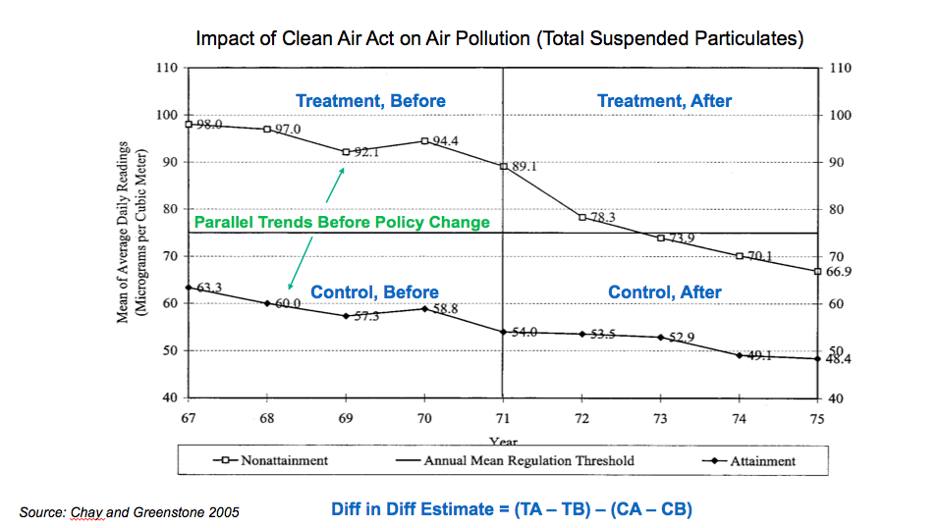
- The assumption we make is that if we did not have this policy change in 1971 then the trends in pollution levels in the treatment areas and control areas would have been parallel to each other. We cannot know whether that would have been the case or not but one way we can assess whether that assumption seems plausible is by looking before the policy change occurred. Here it seems that the answer is yes. When there is a dip, for example in 1969, in the top sequence, there is also a dip in the bottom sequence. In other words, the factors that seem to be affecting pollution in one set of counties seem to be similar to the factors that are affecting pollution in the other set of counties.
- Isen et al. then examined all the economic outcomes at age 30 versus the year in which someone was born, to isolate the causal effects of pollution on kids’ long-term outcomes. It is a very simple idea given the setup. They plot the difference in outcomes between kids who were born in treated counties, so the counties that were non-attainment and were experiencing big declines in pollution, versus the control counties by the year in which children were born.
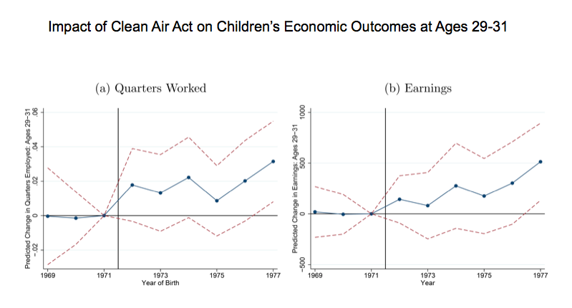
- This plot shows differences in the number of quarters in which someone worked on the left and the difference in earnings on the right, by the year in which you were born. Again, this difference is for these outcomes in the treated areas relative to the control areas. They are subtracting the control from the treatment in each year. We can see that before the policy change, the plot shows a flat line, which is a way of saying there are parallel trends in the two places. They were moving similar to each other and there was no differential trend in employment. Then for kids born right after 1971, in the places where we saw a sharp reduction in pollution, those kids are significantly more likely to be working 30 years later, and they are earning more money. The bottom line of this analysis is it looks like this effort to reduce pollution by the US government had significant impacts thirty years down the road because exposure to pollution when children are born and at very young ages can be detrimental to health, which ends up having downstream consequences.
- To summarize the findings, the authors conclude that the reduction in pollution in the non-attainment counties increases children's earnings by about 1%. That implies that this policy change that would reduce air pollution in the US increased total earnings by above 6.5 billion dollars per birth cohort of kids. That is quite a substantial sum and that even excludes the potential gains that may have accrued to society in other ways independent of how much these kids were earning. The key upshot of this is that this type of policy change has quite large social benefits and they were able to take a step towards quantifying what those gains are.

