Lecture 11: Improving Health Outcomes
Professor Raj Chetty, Harvard University

Improving Health Outcomes: Overview
- What interventions are most effective in improving health kind of holding fixed the current frontier of medical technology?
- “The Association Between Income and Life Expectancy in the United States.”
- We examined the relationship between life expectancy and income in particular, and how that varies across areas and try to understand the determinants of health and equality and life expectancy.
- Estimate the expected age of death, conditional on an individual's income, at age 40, controlling for differences in race and ethnicity.
  - How long will people expect to live given current mortality rates?
- Period life expectancy: measure mortality rates within a given year.
  - Look at data for 2010, measure the fraction of people who die at age 40, 41, 42, 43, and so on. What is the life expectancy for a hypothetical individual who experiences that sequence of mortality rates at each age within 2010?
  - Summarizing what the mortality rates look like, at a given point in time holding technology fixed. This is not the actual life experience of a given person.
- Survival curve: taking a set of men who are at the fifth percentile of the income distribution, at age 40, and we're tracking what fraction of them are still alive at various ages.
  - Starts out at 100%: everyone in this group that we’re looking at is alive at age 40 when we're measuring their incomes. Then we see as people start to die the survival rate falls such that by the time you get to age 76, you have about 50% of men who were at the fifth percentile of the income distribution are still alive at age 76.
  - The survival curve for men who were at the 95th percentile: at age 76, more than 80% of men who were at the 95th percent of the income distribution in their 40s are still alive.
- In the data that we have, we're not able to look past age 76. Gompertz documented that mortality rates grow exponentially with age: m(a) = k$e^{Ba}$
  - If I tell you your age, A, and I estimate in the data K and Beta, I can almost perfectly predict mortality rates at each age.
  - The log of the mortality rate is well described by a straight line: log m(a) = K + Ba
- Plotting the log of the mortality rate on the y-axis. On the x-axis is age. Almost a perfectly straight line. There's a little bit of deviation, as you can see, after age 90.
  - This also holds at each income level. As you get older, in any given year your probability of death rises. However, mortality rates rise more steeply with age for men at the 95th percentile who have much lower mortality rates when they're young than men who are low-income.
- Make a pretty good guess about what mortality rates are going to be after age 76 using this survival model. Find the best fit line and extrapolate it out.

Questions on the Survival Model Method
- Does Medicare have any effect on that relationship in the US data?
  - If you thought it was literally about access to healthcare or health insurance coverage at a given point in time, you would expect this curve to break differently for the low-income men relative to the high-income men after age 65 (when you become eligible for Medicare) and you don't see that. That suggests that at least, healthcare coverage doesn’t seem to be having an impact on what’s going on. It could be that healthcare coverage builds up from much earlier ages.

Descriptive Analysis Continued
- Take national data on mortality rates after age 90.
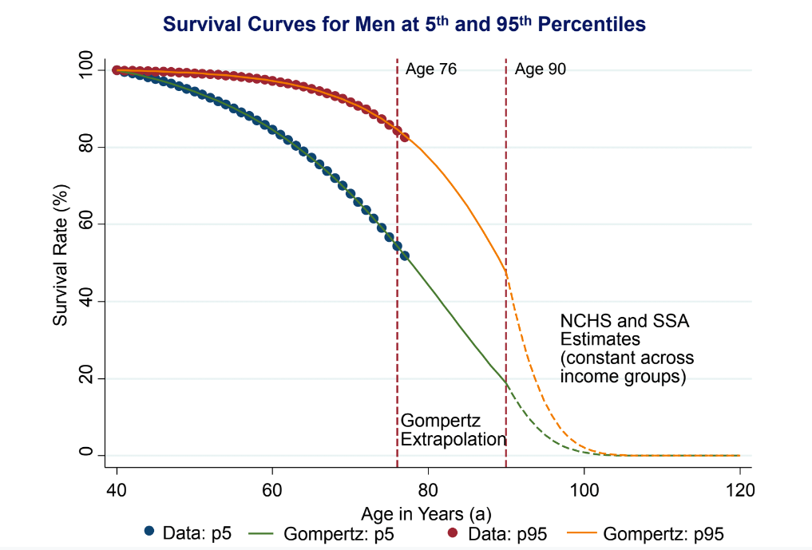

National Statistics on Income and Life Expectancy
- Using those survival curves, construct estimates of life expectancy, which is just the average length of life for a given person given all these mortality rates. imagine taking all of that data and computing the average value. What's the expected point at which people are going to die based on their income?
- The relationship between life expectancy and income is upward sloping. Life expectancy ranges from about 72 years for men at the bottom of the income distribution up to about 87 years for men at the top of the income distribution—an enormous difference.
- The richest men in the US have a life expectancy that's higher than average life expectancy in any country in the world. The lowest income men in the US, in the bottom percentile, have a life expectancy fairly close to the life expectancy in Sudan: tremendous health inequality.
- The gap in life expectancy between the bottom and the top of the income distribution for women is about 10 years rather than 15 years. Women tend to live longer on average than men. Near the very top of the income distribution, there's only about a one or one and a half year gap in life expectancy between men and women. Then at the bottom, you have this enormous gap because low-income men have extremely high mortality rates in their 40s, 50s, and 60s, relative to men with higher income (potentially because of poverty, biology, resiliency, or other environmental factors).
- Life expectancy is going up over time for all income groups, but it's going up much more rapidly for people at the top of the income distribution than it is for people at the bottom of the income distribution.
  - Over the past 15 years, there's been about a three year increase in life expectancy for high-income Americans. There's been about a one year increase in life expectancy for low-income Americans. For the bottom 5%, you find essentially no progress at all. This is not about technological improvement, but unequally distributed gains in terms of health.
  - For women, you see a very similar pattern that is slightly accentuated.

Local Area Variation in Life Expectancy by Income
- If you're rich, it doesn't matter where you're living, your life expectancy is pretty similar and it's quite high. However, if you're poor, there's quite a bit of variation in life expectancy across places.
  - In New York City, low-income men live on average about six or seven years longer than low-income men in Detroit. The CDC estimates that if we were to eliminate cancer as a cause of death in the US, average life expectancy would increase by 3.2 years. So six or seven years is twice as large.
  - That pattern is also evident for women. In certain cities for women, you can be a low-income woman in New York City and have almost the same life expectancy as an upper-middle-class woman. In Detroit you can see that that's not the case. All of this as being adjusted for differences in race and ethnicity in the background.
- Life expectancy among low-income people: lowest levels of life expectancy are concentrated in the industrial Midwest, and south from that area. If you instead construct a map of just life expectancy on average pooling all income groups you see the lowest levels of life expectancy in the Southeast.
  - When you have a larger concentration of low-income people (Southeast), you end up with lower levels of life expectancy. That's what this map that pools across all income groups is showing you. The map that shows life expectancy among the bottom quartile is showing you that controlling for income among low-income people, health in the Southeast is not exceptionally poor.
  - It suggests that some of the poor health outcomes that we're seeing in the Southeast might not be about health per se, but rather about income or a broader set of factors that are associated with low levels of income that are then associated with poor health outcomes as well.
- Conditional on income, you actually have higher levels of life expectancy if you're a poor woman in the Southeast than if you are a poor woman in the Industrial Midwest.
- Places with high life expectancy for low-income people are broadly affluent coastal cities. Places with low life expectancy for low-income people are broadly in the industrial Midwest.

Why Does Life Expectancy for Low-Income Individuals Vary Across Areas?
- Is the lower life expectancy in some areas driven by a lack of access to healthcare or is it driven by differences in health behaviors?
  - Correlating life expectancy estimates with measures of health care access and health behaviors.
- The fraction of people who are smokers among low-income individuals in an area has a correlation of -0.7 with life expectancy, which is an incredibly strong correlation. Obesity has a correlation of -0.5, while exercise rates have a correlation of +0.3.
- In much of the Southeast, you actually have lower rates of smoking conditional on income than in places like Appalachia, where you have the darkest red colors and you also have the lowest life expectancy. You get a correlation of 0.7 between smoking rates and life expectancy because the life expectancy map and the smoking map look incredibly similar.
  - If you look at the scale, the fraction of smokers is going from 20% to 35%. That is not a big enough effect to explain the three, four-year gaps we found across places.
- There’s a clear, strong association of life expectancy with measures of health behaviors.
- It's not actually the case that places with lower rates of health insurance coverage have lower levels of life expectancy. There's not much of an association at all.
  - That does not mean that healthcare access has no causal effect on life expectancy. This is telling you is that the differences across areas in levels of life expectancy are not readily attributed to those types of differences in healthcare access. If you are in dire need of medical care, you can go to an emergency room, even if you don't have health insurance in the US.
- This analysis comes out pretty strongly in favor of the health behaviors view rather than the healthcare access view.
- Affluence and education have very strong correlations.
  - Low-income Americans have high life expectancy in places with many immigrants, very high house values, high population density, a large fraction of college graduates, and better health behaviors.
- Potentially, there is a causal effect of living in these cities:
  - If you're around a bunch of other people who are eating healthier, exercising, etc., maybe that influences what you choose to do and then that changes your own health.
  - Supply side: if you've got a huge base of people who are interested in buying healthy products, as opposed to cigarettes, you were going to have a different supply of stores in a given area and that might end up affecting what other groups in the population end up choosing to do.
  - The types of low-income people who live in San Francisco and New York versus the types of low-income people who live in Gary, Indiana.
- Trying to show causality: when people move to an area with higher mortality rates the year after they have somewhat different mortality rates themselves (Amy Finkelstein). However, the effect is not huge..
- Key takeaway: systematic differences across places and low-income people's health outcomes that seem to be channeled through differences in health behaviors.

Questions on Why Life Expectancy for Low-Income Individuals Varies Across Areas
- Does your analysis of the best places for low-income Americans to have long life expectancies adjust for the cost of living in those various cities?
  - No, and that makes it all the more striking that you see this pattern.
- There are probably fewer people who are earning $25,000 in New York than in Indiana. Does that affect our results?
  - In absolute terms, incomes vary between places. Places like New York are more affluent. You'd worry about that if the sample were so small that there was hardly any data there. That is not the case because we're working with the entire population.

Differences in Nutrition by Income
- Health behaviors: Alcott and peers use Nielsen home scan data on grocery store purchases to examine how nutrition varies with income.
  - The highest-income Americans are eating about half a standard deviation more of healthier foods than the lowest-income Americans: a substantial shift.
- These differences seem to be about different choices that people are making, not really differences in access to the types of foods people have.
  - Control for the set of grocery stores you could go to in your area. Even when you compare people in the same zip code, low-income people are eating less healthy food than high-income people. Controlling for shopping at the same chain: same results.
  - Imagine a new chain opens in a given place that maybe stocks healthier foods. Does that affect the choices that low-income people make? They find that has essentially no impact. When you look at where people shop, it's actually not super close to where they live.
- Differences in health outcomes across income groups don't appear to be caused by direct lack of access to resources.
- Why do low-income households tend to have less healthy behaviors? Behaviors themselves are the product of preferences and environment.
- Hypothesis 1: the effects of environment and resources at earlier ages on people's preferences (David Atkin).
  - The nutritional habits that people formed at young ages, based on whatever region in India they were in, persist for many years, even after people move to a different region.
  - If the thing that you're used to eating is now more expensive, the preferences are so strong that you actually eat less.
  - This suggests that changing resources, maybe even healthcare, at that earlier stages in people’s lives would then shape the trajectory that people follow.
- Hypothesis 2: a lack of income constrains choice. Unhealthy foods maybe are less expensive per calorie.

